

**Heritage Montgomery Mini Grants**

**FY 2020 Guidelines**

Deadline: Thursday, September 19, 2019

For projects to be completed by June 30, 2020

Awards announced mid-October 2019

red = changes for FY 2020

Heritage Montgomery

12535 Milestone Manor Lane

Germantown, MD 20876

301.515.0753

director@HeritageMontgomery.org

**Introduction**

Heritage Montgomery (HM) Mini Grants of $500 to $2500 are awarded annually for activities that promote heritage tourism in Montgomery County and are consistent with the mission of Heritage Montgomery:

* Enhancing Montgomery County’s appeal to travelers who love history and culture
* Encouraging residents and visitors to understand and appreciate the history, culture, and natural areas of the county
* Promoting tourism and economic activity
* Fostering preservation and stewardship of historic buildings and sites
* Providing and encouraging others to provide interpretive and educational programs and services about local heritage
* Implementing, within Montgomery County, the provisions of the Maryland Heritage Areas Authority

**Eligibility**

Organizations interested in applying for a Mini Grant **must** first discuss the proposed project with HM Executive Director Sarah Rogers (301-515-0753). Applications submitted without first reviewing with the Executive Director will not be considered.

Organizations must meet one of these criteria for the past 24 months:

* Be a 501(c)(3) nonprofit, based in Montgomery County, MD
* Be an incorporated municipal government entity located in Montgomery County, MD
* Be located within the boundaries of the Montgomery County heritage area

**Organizations in receipt of past Mini Grants must have met the Grant Requirements for that award.**

**Funding Priorities**

Activities in support of the Heritage Days and Emancipation Day programs and projects specific to HM themes of Rivers, Roads, & Rails (Transportation Trails), Crossroads & Cultures (African American & Quaker Heritage), the Agricultural Reserve (Farms, Markets, & Scenic Byways), and Heritage Gems (Montgomery County’s Past) will be given special consideration.

**Application Format**

Complete and submit both the Mini-Grant Application Narrative and Budget documents available on the HM website. Note that we have also provided a Sample Budget that may be helpful as you complete your application Budget form.

**Submit each component of your application as an individual document, not as one joined pdf document.**

**Submit your Budget form as a Word document.** If there are any small changes that need to be made HM can, with your approval, make minor adjustments without sending the form back to be re-done.

**Matching Requirements**

In the project Budget, applicants must show a **one-to-one match** equal to the grant funding requested. In other words, the total project Budget must be at least two times the amount of the grant requested. This match must consist of **at least 50% cash** and **no more than 50% in-kind** contributions OR the match may be entirely cash.

For example, if your total project expenses (cash & in-kind) equal $1000, you may request $500 from HM. Your organization must show a total match of $500; at least $250 in cash and no more than $250 in-kind.

Your project does not have to cap at $5000. If the total cost of the project exceeds $5000, you may request $2500 from HM and show your additional project funding (cash/in-kind) in your project Budget.

**For projects with a total cost of $5000 or less:**

* Organizations may request a Mini Grant of up to 50% of the total project cost.
* The cash match must equal at least 50% of the grant request; any in-kind match can equal no more than 50% of the grant request.

**For projects with a total cost of over $5000:**

* Organizations may request a Mini Grant of up to $2500.
* The match must equal at least $1250 cash and no more than $1250 in-kind. Your Budget must also reflect the additional cash and in-kind expenses and income for the project.

In-kind contributions to a project may consist of:

* Donations of materials/supplies – documented at market value
* Volunteer time for work on the project – valued at $25/hour
* Donated professional services (i.e. an attorney reviewing legal documents) – calculated at their professional rate. Your organization’s paid staff time spent on the project is NOT allowable as an in-kind expense.

Your project Budget should include only expenses and income specific to this particular project/program. Total expenses must equal total income. For example, if volunteer time is shown as an in-kind donation, it must also be shown as an in-kind expense.

For further clarification, see the **Sample Budget document** that is included with FY20 application materials on the HM website (Partners/Grants/Mini Grants).

**Budget Form – Expenses**

* Column A Indicate the total expense of each line item in your project.
* Column B Indicate the cash expenses that will be paid for with Mini-Grant funds.

Subtotal must equal your Grant Request.

* Column C Indicate the cash expenses (match) to be paid with your organization’s funds; subtotal must equal at least 50% of your Grant Request.
* Column D Indicate the value of in-kind contributions (match); subtotal must

equal no more than 50% of your Grant Request.

* Note: The subtotal of columns C + D must equal your Grant Request.
* Column E Any additional cash expenses for your project (if your Total Project

Expense exceeds $5000).

* Column F Any additional in-kind donations for your project (if applicable, and

your Total Project Expense exceeds $5000).

* Total Project Expense must equal the total of columns B thru F.

**Budget Form – Income**

* Cash Income Subtotal must equal the subtotals of columns C + E on page 1; and must equal at least 50% of your Grant Request.
* In-Kind Income Subtotal must equal subtotals of columns D + F on page 1.
* Total Project Income equals Cash Income + In-Kind Income + Grant Request;

must equal the Total Project Expense on page 1.

**Grant Restrictions**

Heritage Montgomery Mini Grants cannot fund:

* General operating expenses, such as salaries for staff
* Capital expenditures
* Refreshment costs
* Fundraising activities, debt retirement, or political advocacy
* Scholarships or tuition assistance
* Activities for the exclusive benefit of an organization’s members

Activities eligible for funding include, but are not limited to:

* Heritage Days events
* Tours/trail development
* Educational and interpretive events/programs
* Displays and exhibits
* Website improvement
* Logo and identity development
* Interpretive panels and signage
* Museum and collection management materials and software

**Final Report**

Grant recipients must submit a Final Report (template included with grant award materials) to HM **no later than** one month following the end of the grant period (July 31, 2020). The report **must** include:

* A narrative description of the completed project.
* Proof of all expenses included in the budget submitted with the Mini-Grant application (including total expenses and income for projects over $5000). Grantee must provide financial documentation of all project expenditures, matching cash, and in-kind contributions utilized. **Copies of invoices, receipts, cancelled checks will be required.**
* A summary document listing all project invoices and documented in-kind donations and cash income that are being submitted with the final report.
* Copies of any printed materials associated with the project (including press releases, newsletter, emails to membership) acknowledging Heritage Montgomery, Maryland Heritage Areas Authority, and Montgomery County Government.
* Photograph/s of the completed project.

**Grant Requirements**

1. All applicants **must** discuss their proposed project with HM’s Executive Director **prior to** submitting a Mini-Grant application.
2. Applicants are encouraged to participate with free admission in Heritage Days. If you do not plan to participate, please discuss with HM prior to submitting your Mini-Grant application.
3. Heritage Montgomery encourages all grantees to inform Montgomery County Council members of the funds awarded through HM and the project the grant will fund.
4. Grant recipients **must** send HM advance notice of events/programs their organization sponsors throughout the year for inclusion on the HM website calendar.
5. Recipients participating in Heritage Days **must** publicize the event as a whole on their website, in social media, etc. and not just the specific event at their site.
6. Heritage Montgomery and the grantee will conduct a mid-project review that will take place before printing or fabrication. Grant recipients **must** contact Heritage Montgomery by mid-November 2019 to schedule the mid-project review.
7. Heritage Montgomery must review all funded projects prior to execution of the final product.
8. Grantee must submit a Final Report with proof of all completed work. The report must document how the grant funds and match were utilized. The Final Report form is due to HM no later than one month following the end of the grant period.
9. If awarded, the project must be completed by June 30, 2020 unless an extension has been granted (see Changes in Project Implementation, below), or the applicant must return all funds.
10. Heritage Montgomery, Montgomery County Government, the Maryland Heritage Areas Authority (MHAA) **must** be acknowledged in all formats of all materials relating to the project, including press and publicity. Logos of all three entities must appear along with the accompanying text, as shown below. NOTE: Failure to include logos and accompanying text on all project-related printed/electronic material may disqualify organizations from future grant awards.

Failure to meet these requirements could result in future ineligibility for Mini-Grant awards.

**Logos:**

 Heritage Montgomery

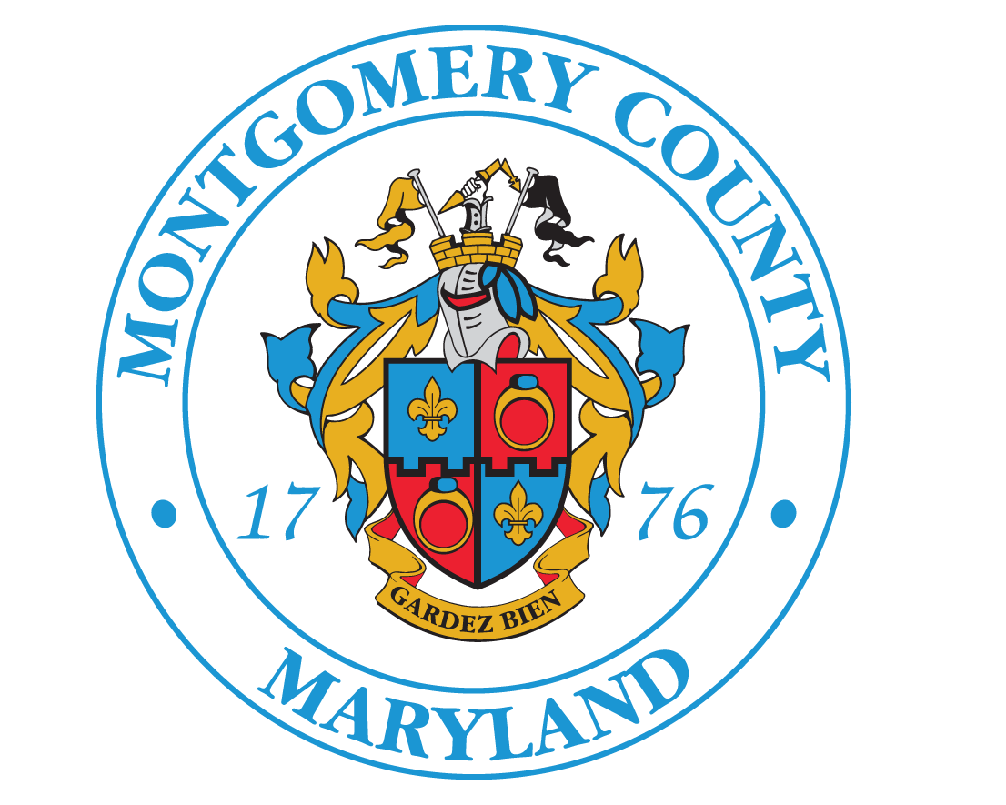 Montgomery County Government

This project has been financed in part with funds from Heritage Montgomery and Montgomery County Government.

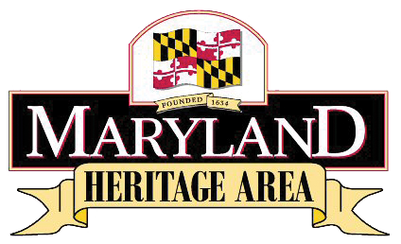 Maryland Heritage Areas Authority

This project has been financed in part with State Funds from the Maryland Heritage Areas Authority, an instrumentality of the State of Maryland. However, the contents and opinions do not necessarily reflect the views or policies of the Maryland Heritage Areas Authority.

**Changes in Project Implementation**

* If it becomes impossible to complete the project by the deadline due to unforeseen circumstances, the grantee must request an extension in writing no later than Thursday, May 7, 2020.
* Any change in a grantee’s program content must be requested in writing and approved by HM before the change occurs.

**Support Documents**

Required support documents include:

* Resumes of project lead and any contract/special resource personnel
* List of the organization’s current Board of Directors, with addresses, OR, if the applicant is a municipality, list of current elected officials
* Heritage Montgomery strongly encourages applicants to submit support materials/documents that help explain your organization and project. This could include, but is not limited to, photographs, brochures, materials related to similar projects, annual reports, event programs, and press clippings.

**Evaluation Criteria**

1. **Heritage Days Related**: Will this program be developed for Heritage Days? Can this program be used throughout the year as part of regular programs?
2. **Impact on Heritage Tourism**: How will this project contribute to carrying out the mission of Heritage Montgomery?
3. **Program Effectiveness**: How will this project achieve its intended purpose?
4. **Qualifications**: Are the individuals working on the project qualified to carry out the task identified?
5. **Organizational Capacity**: Does the organization have the management skills, experience, and staffing to carry out the proposed project/program?
6. **Budget**: Is the budget appropriate for the scale of the project/program and the intended product? Do the sources and amounts of matching funds anticipated appear to be attainable? Are budget numbers/calculations accurate?
7. **Likelihood of Completion**: Is this a well-planned project that can be completed in the time frame specified?
8. **Grant Requirements: How well has the organization met the FY20 grant requirements and, for past Mini-Grant award recipients, how well have they met requirements for their previously awarded grants?**

**Grant Submission**

* Completed Mini-Grant applications (narrative, budget, and support materials) are due to Heritage Montgomery by 4pm on Thursday, September 19, 2019.
* Submit electronically to Director@HeritageMontgomery.org, Lori@HeritageMontgomery.org and info@HeritageMontgomery.org

**Grant Awards**

Grant awards will be announced in mid-October and Grant Award Agreements will be emailed to awardees. Seventy-five percent of awarded grant funds will be dispersed upon receipt by HM of a signed Grant Agreement and the remaining twenty-five percent upon timely submission of the completed Final Report.

**Deadlines**

Monday, Sept. 9, 2019 Optional review of final application by HM staff

Thursday, Sept. 19, 2019 Application due to HM by 4pm

Mid-October 2019 Announcement of awards – grant period begins

Mid-November 2019 Deadline to contact HM to schedule mid-project review

Thursday, May 7, 2020 Extension request due, if needed

Tuesday, June 30, 2020 Grant period ends – project must be complete

Friday, July 31, 2020 Final Report due